The Contents of BOC / BOR / STF / ELG / SIN / DIR

BOC File
File Format

MXD Header
Schema
Command Data
X 1
CRC
Sequence Number *
Command
String Parameter
Number Parameter

A boc file contains the following data:
Field | Type | Description
SerialNo | Int | The sequence number to send back in the response file on completion
Command | enum | The command the machine should perform (see previous)
NumPar1 | Int | Numeric parameter, e.g. a Unix time for SET_CALL_TIME
StringPar1 | String | String parameter, e.g. the name of the ELG file to upload

Sample file
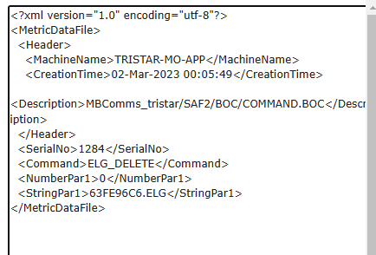

If the body of Http is empty, the current communication is ended.

BOR file
File Format

MXD Header
Schema
Response Data
X 1
CRC
Sequence Number *
Status (Response)

* The Sequence Number shall be same to the Sequence Number of BOC

Field | Type | Description
SerialNo | Int | The sequence number of the completed command
Response | enum | The response state to the command

Response enum:
SUCCESS,
FILE_NOT_FOUND,
INVALID_CMD,
HTTP_FAILURE,
FILE_CREATE_FAILED,
FILE_RENAME_FAILED,
INVALID_FILE,
COMMAND_FAILED,
WRONG_FILE_EXTENSION

Sample file
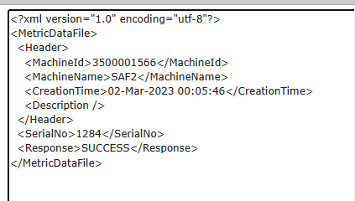

SIN
File Format
System Information
- Application version
Date / Time Created
- Configuration Version
Date / Time Created
- TRF file Active Version
Date / Time created
- Card Reader Type
Windcave BRF210F
- Card Reader HW version
- Card Reader FW version

MXD Header
Schema
SIN Data
X 1
CRC

Need SIN Xsd file from Sandy

Sample File
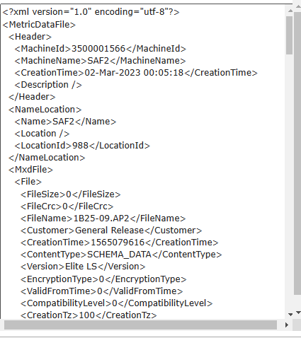

DIR
File Format
List of Files Requested
- File Name -- String
- File Type -- String
- Size -- INT
- CRC – 4 bytes
- Created D/T – 4 bytes timestamp

MXD Header
Schema
DIR Data
0 to N
CRC

Refer to filelist.xsd

Sample files:
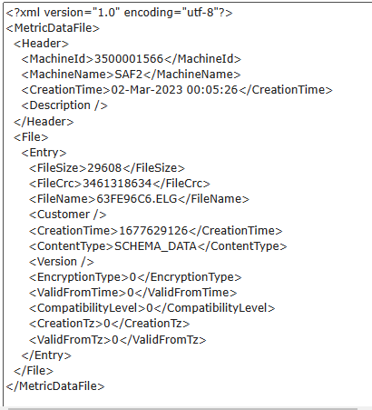

ELG
File format

MXD Header
Schema
Event Data
1 to N
CRC
List of Files Requested
- File Name -- String
- File Type -- String
- Size -- INT
- CRC – 4 bytes
- Created D/T – 4 bytes timestamp

29 Different Event Types, For Micro, there are 6 event types.
1, Status Flags – EVENT_LOG_STATUS_FLAG_CHANGE
2, Machine Startup –EVENT_LOG_STARTUP
3, Transaction Data -- EVENT_LOG_AUDIT_TRANSACTION
4, Payment Data -- EVENT_LOG_AUDIT_CARD_DEBIT (for OK)
5, Payment Data -- EVENT_LOG_AUDIT_CARD_NON_PAYMENT (For failure)
6, PSU Data -- EVENT_LOG_PSU_STATUS

Refer to event.xsd

For example:

Event Data
2 Machine Startup
- Status Change
- Status Change
6 PSU Data
3 TX Data
4 Payment Data (OK)
3 TX Data
4 Payment Data (OK)
5 Payment Data(Failure)
6 PSU Data
CRC

Sample file:
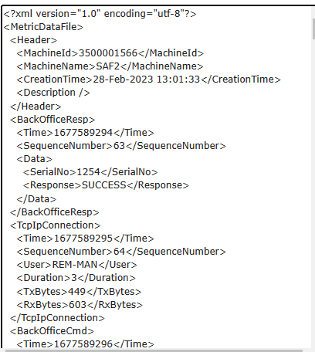

STF
File Format

MXD Header
Schema
Battery Voltage
B1 / B2
Coin Note
Ticket Stock L/R
Flags
0 to N
CRC
- Device ID
- Device Description
- Flag ID
- Flag Description
- Level

Refer to status.xsd

For example:
Device ID Device Desc Flag Flag Desc Level
7 Card Reader 16 Comms Fail E
6 External 16 External Payment E
17 General 15 Out of Service E
17 General 0 In Service I

Events Sequence:

- Card Reader comms failure 7, 16, E
- No payment method, out of service 17,15, E
- Maintenance Service Menu 6, 16. E
- Fix issue 17,0, I

STF files
A，B –> STF1
A，B，C STF2
D –> STF3

Notes:
1, Any Change to Status
Do a back office call.
1-1,Sends STF
1-2, Do BOC

2, If machine is OK
2-1, STF flag is 0 (blank).
2-2, If STF has 0 flags, machine is OK.

Sample Files
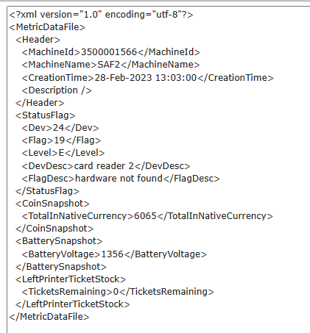

Build an array or collection to store all active flag devices need to be monitored.
Once a device goes wrong, the device will be moved into array or collection. If the device is recovered, remove it from the array or collection. Every time there is a change to the array or collection, it triggers a STF call.

Active flag means the device is going wrong.

